19th Key Symposium: Planetary Health – connect the dots. What saves the planet saves our health
19-21 May 2025 at the Royal Swedish Academy of Sciences, Stockholm, Sweden
Planetary Health – connect the dots. ‘What saves the planet saves our health’
Aim of meeting: A multidisciplinary approach to increase the understanding of how a changing environment will impact future human health and wellbeing. 39 invited speakers and opinion leaders presenting 18- min lectures. 100 discussants include medical doctors, climate researchers, chemists, veterinarians, ecologists, biologists, anthropologist’s, epidemiologists, nutritionists, technicians, geographers, geologists, meteorologists, aerosol scientists , geoscientists, toxicologists, journalists .
Venue: Beijersalen, KVA (138 seats) Organizing committee : Peter Stenvinkel , Karolinska Institutet peter.stenvinkel@ki.se
Maria Borelius moderator
Prof. Annika Wernerson, President Karolinska Institutet. Health is extensively influenced by climate change. Bio centric approach. Climate change perhaps easier to solve than loss of biodiversity. Connecting the dots. Integrating research and teaching.
Prof Jan Nilsson Royal Swedish Academy of Sciences. The world is currently upside down. Trump is promoting global warming and fact resistance.
Isabella Lövin. The problem of denial among politicians. When we burn up the planet, we burn out ourselves. Oceanic feeling, being part of nature, not understood by Freud. Romain Rolland 1927 coined the phrase "oceanic feeling" to refer to "a sensation of 'eternity'", a feeling of "being one with the external world as a whole", inspired by the example of Ramakrishna, among other mystics.
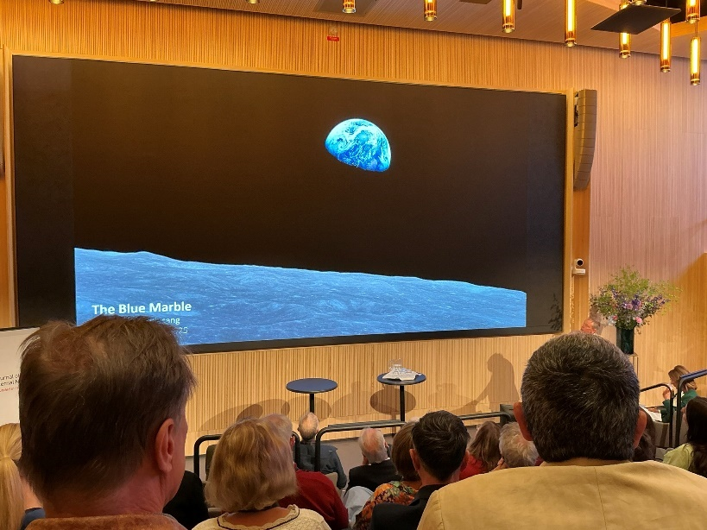
Bo Angelin, Axel Key former rector of KI started 1863 JIM, Journal of Internal Medicine - Wiley Online Library previously Acta Medica Scandinavica. 9% acceptance rate. IF 9,0 Major supporter of this meeting
The blue marble. Christer Fuglesang cfug@kth.se A planet for everyone. Iconic picture from Apollo 8. The blue marble does not show borders. Circling time 90 min. The Aral Sea 1985 mostly disappeared in 30 years. Extraterrestrial health, radiation and weightlessness are the major health risks. Suggest sunshade introducing a man made screen as a Planetary Sunshade Disk between our earth and the sun. Covering a bit 1% of the sun’s surface to reduce global temperature.

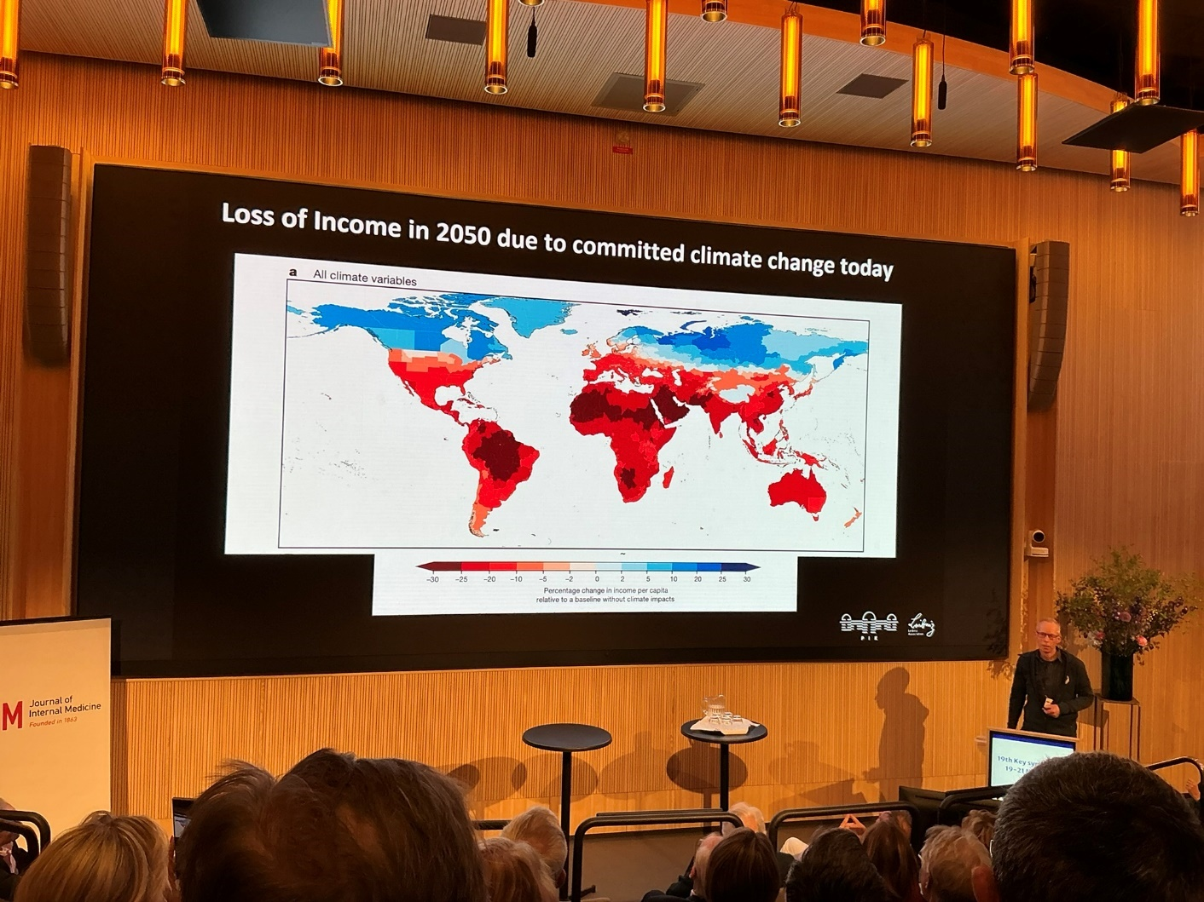
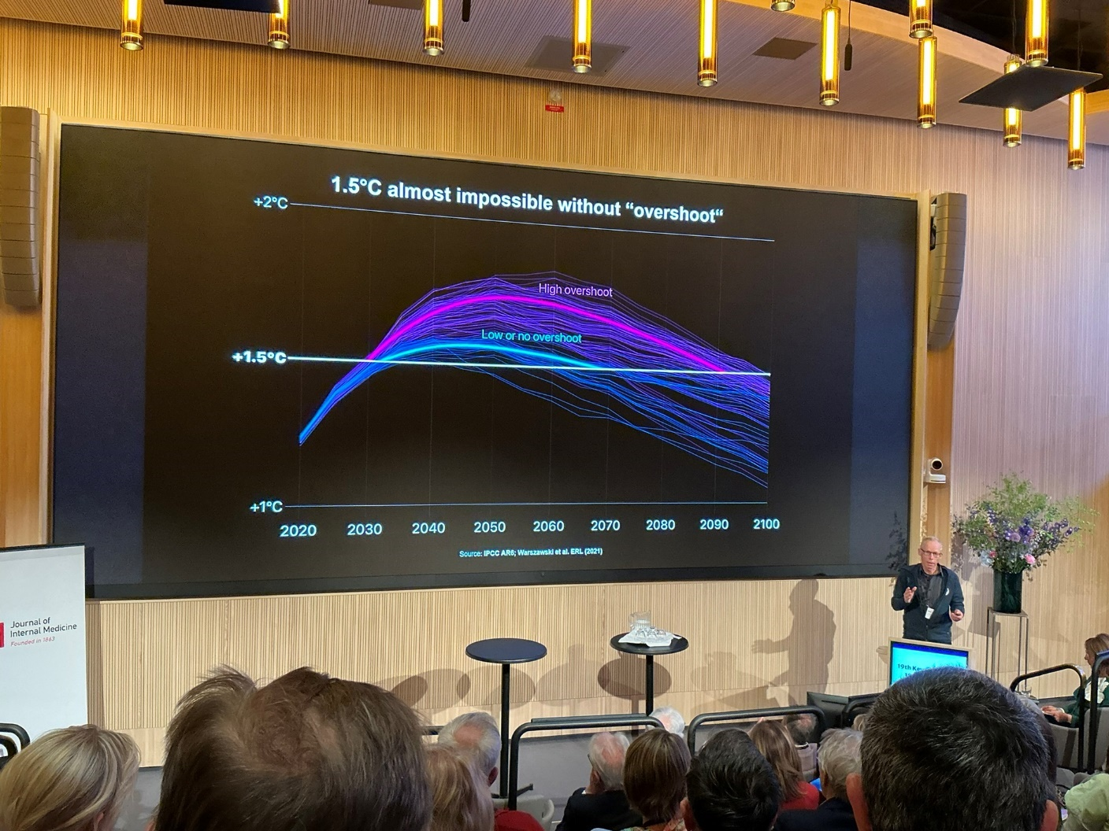
Johan Rockström ( YES ) , Professor Potsdam Institute for Climate Impact Research, sabine.friedel@pik- potsdam.de johan.rockstrom@pik- potsdam.de Germany. We are at risk of destabilising the stability of the earth. 2024 and 2025 warmer than ever seen before. The earth is losing resilience. 1,2 degrees increase. The corridor is -5 to +2,0 - outside this range tipping. We must stay within the planetary boundaries. It will get worse before it gets better. Solutions are available – but need to be implemented, and soon.

Environmental Epidemiology to Planetary Health: Josep M. Antò Boque Director of the Centre for Environmental Epidemiology Research, Barcelona, Spain josepm.anto@isglobal.org . How come environment is degraded but human health improving, this is paradox. Earth is beyond six of nine planetary boundaries. Mitigation of co-benefits for planet as well as human health.

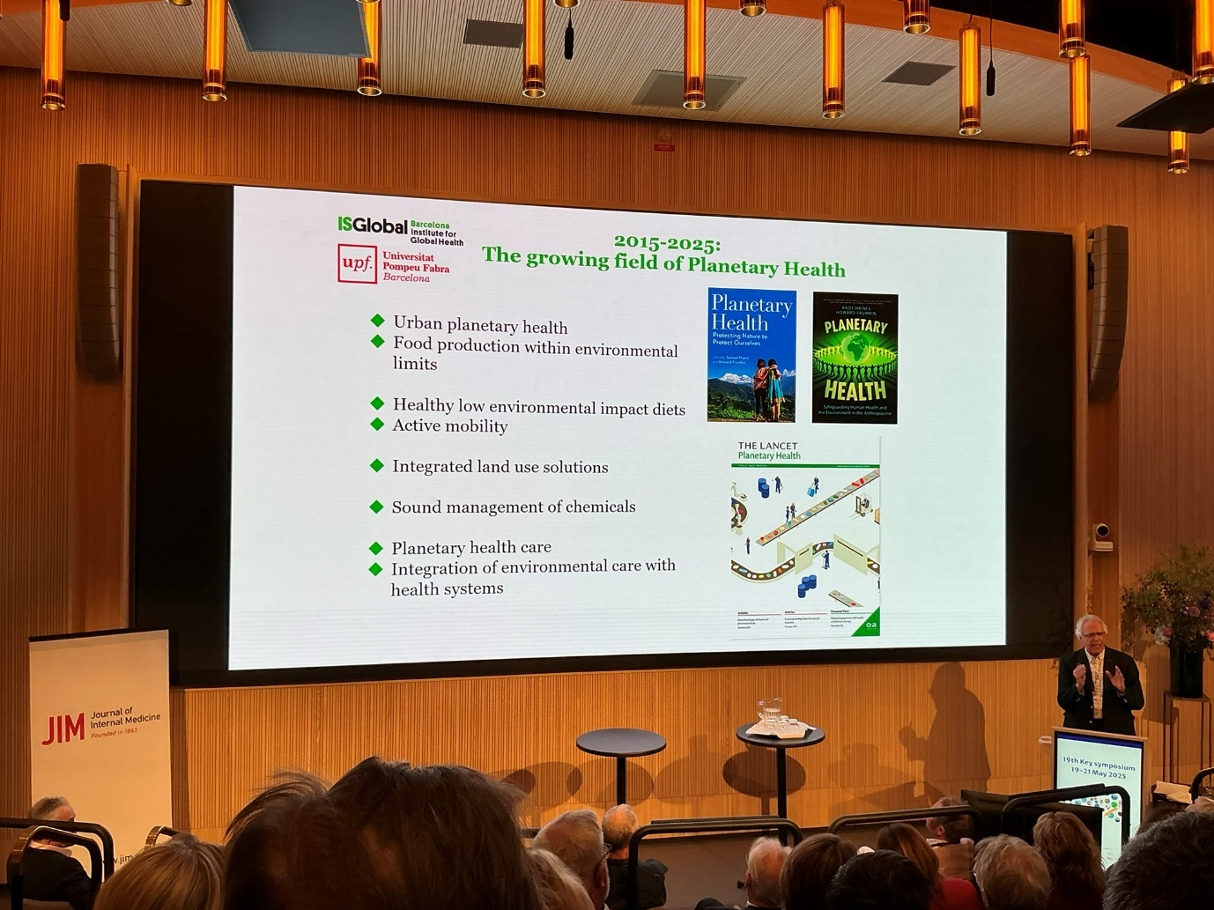
One Health and planetary health research: leveraging differences to grow together Rafael Ruiz de Castañeda Institute of Global health, University of Geneva, Switzerland rafael.ruizdecastaneda@unige.ch . Planetary Health Alliance 201?
One health and planetary health - are complementary. Snake bites a serious problem in sub-Saharan refugee camps.
Community- based interventions to advance climate change resilience Jan C. Semenza Formerly Head of Health Determinants Section at the European Centre for Disease Prevention and Control. jan.semenza@lateralphc.com . See HEAT-RELATED DEATHS DURING THE JULY 1995 HEAT WAVE IN CHICAGO NEJM 1996;335:84-90 social isolation comprised a major risk. 2022 60 thousand in Europe heatwave. Community outreach may attenuate health effects from heat waves. Look for interdisciplinary actions and community actions. Systemic resilience.
Discussion: The beauty of this globe. Corporate greed as the cause suggested some. Social scientists are needed. How do we make a change? Medical students will be dealing not merely with patients but also planetary health. State of urgency. Good leaders are needed, convince the pope! Ozon is a success story. Inform,
Environmental history: Professor Sverker Sörlin, specialist in the history of environmental field sciences, KTH, Stockholm sorlin@kth.se Gilgamesh 2000 BC Hippokrates BC were aware of the association between human and environmental health. Book on Road to survival by Vogt. Rachel Carson wrote in the New Yorker before publishing Silent Spring. Barbara Ward and Rene Dubos. Evolution of knowledge and ideas.
Planetary Health Emergency – How can we act? Martin Herrmann, chair of the German Climate Change and Health Alliance, Germany , m. herrmann @klimawandel- gesundheit.de How can we act? Large transformation is urgently needed. Connecting the action dots. Oceanic feeling, why this is so important. Life and the blue marble globe are precious gifts. Health professionals for heat wave protection. When we realise what is at stake we act! Evidence is at hand, action is needed.
Creating climate- informed physician leaders Jay Lemery, M.D. Climate and Health Program, University of Colorado School of Medicine, Aurora, CO, USA john.lemery@ucdenver.edu
Climate and Health program. Climate change is a disease of infections, lung disease etc … lack of leadership! The poor and sick are the most vulnerable. Send john.lemery@ucdenver.edu JIM paper!
Discussion: Doctors have the public trust; this is an important leverage for change. Focus on things that are close, happening in a near future. What is in it for me. Risk heatwave is an example.
Effects of climate change in daily life: Kimberly Nicholas, Lund kimberly.nicholas@LUCSUS.lu.se (see photos) see We Can Fix It | Prof. Kimberly Nicholas | Substack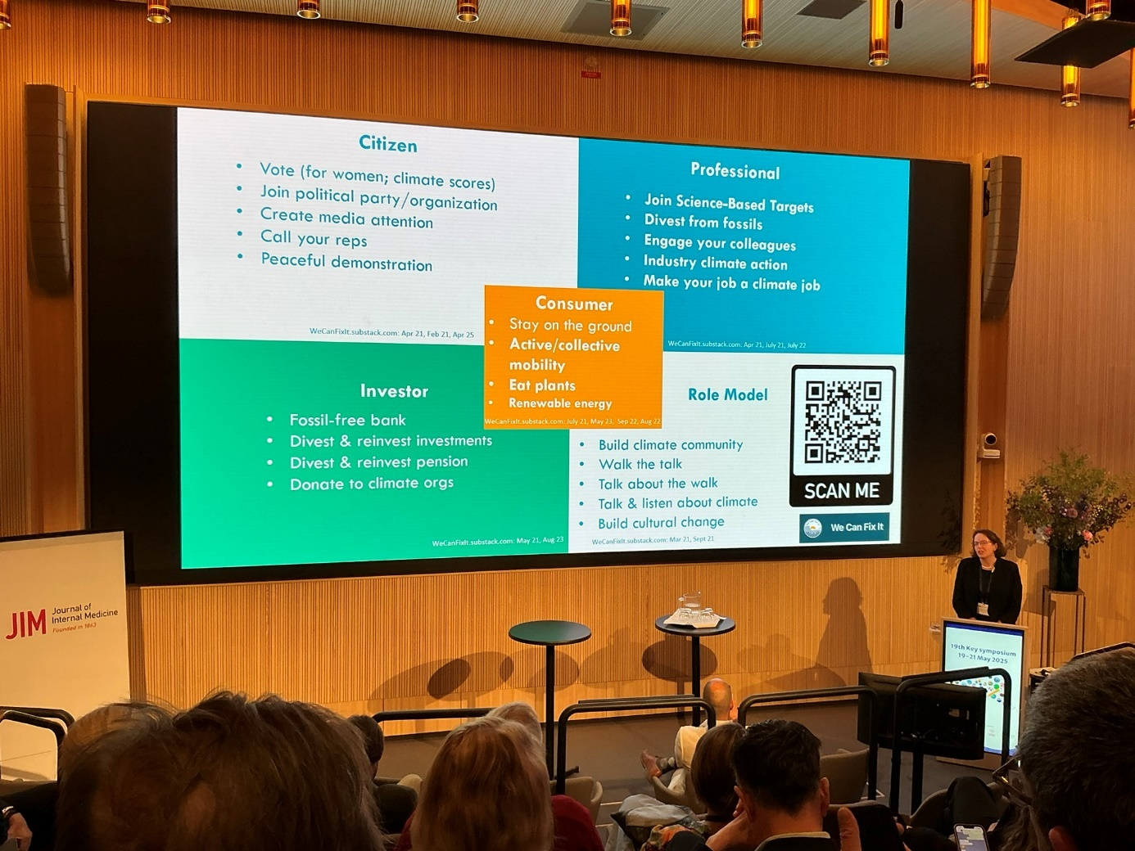
Climate migration Sonja Ayeb Karlsson University College of London , UK s.karlsson@ucl.ac.uk
Biological diversity – a key for human and planetary health Alexandre Antonelli Professor of biodiversity and Director of Science, Royal Botanic Gardens, Kew Gradens, UK a.antonelli@kew.org
Around 80 000 species of animals 400 000 of plants . Three monoculture crops, wheat, rice and maze comprise main human food. 73% decrease in vertebrate populations since 1970. For plants it is even worse. The importance of science-based restoration of biodiversity.
Nutrition – A global challenge for health : Gunhild Stordalen founder and executive chair of EAT. Oslo, Norway gunhild@eatforum.org , gunhild@stordalenfoundation.org
Food can fix it! Global food production has increased more than the global population. 40% of global population are overweight, 10% are hungry. The current global food system is catastrophic! The EAT Lancet report 2024. ‘We can solve the problem if we want to’ Food production, and overproduction, is the culprit

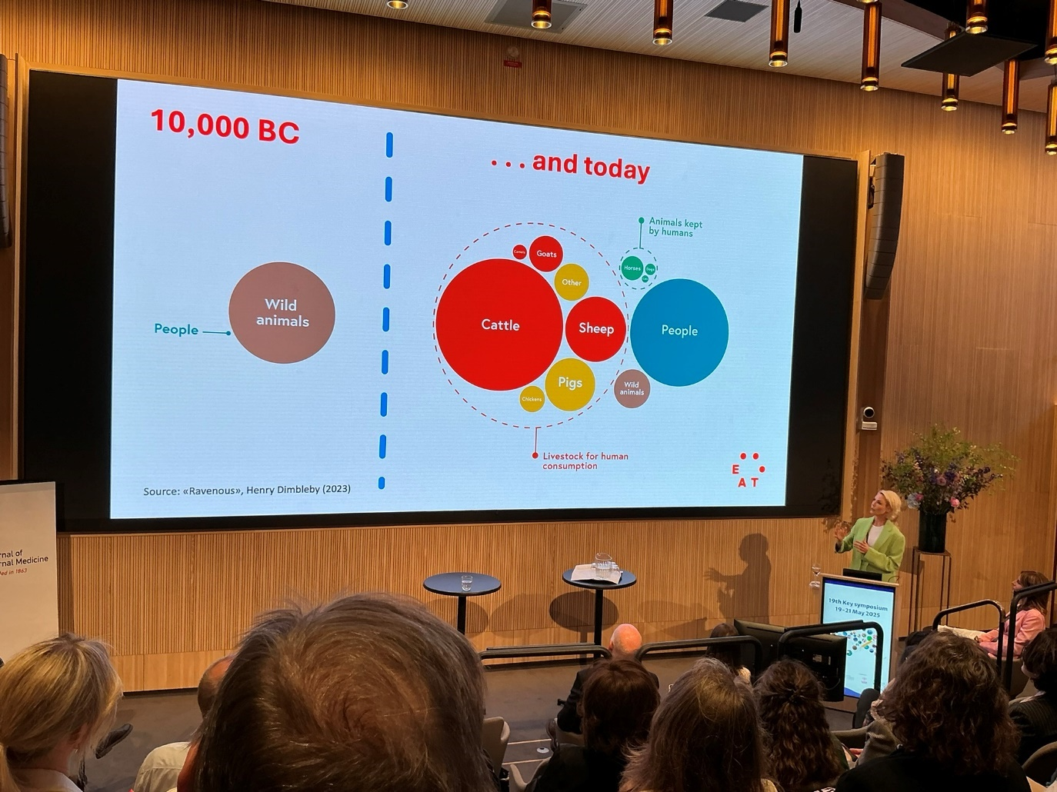
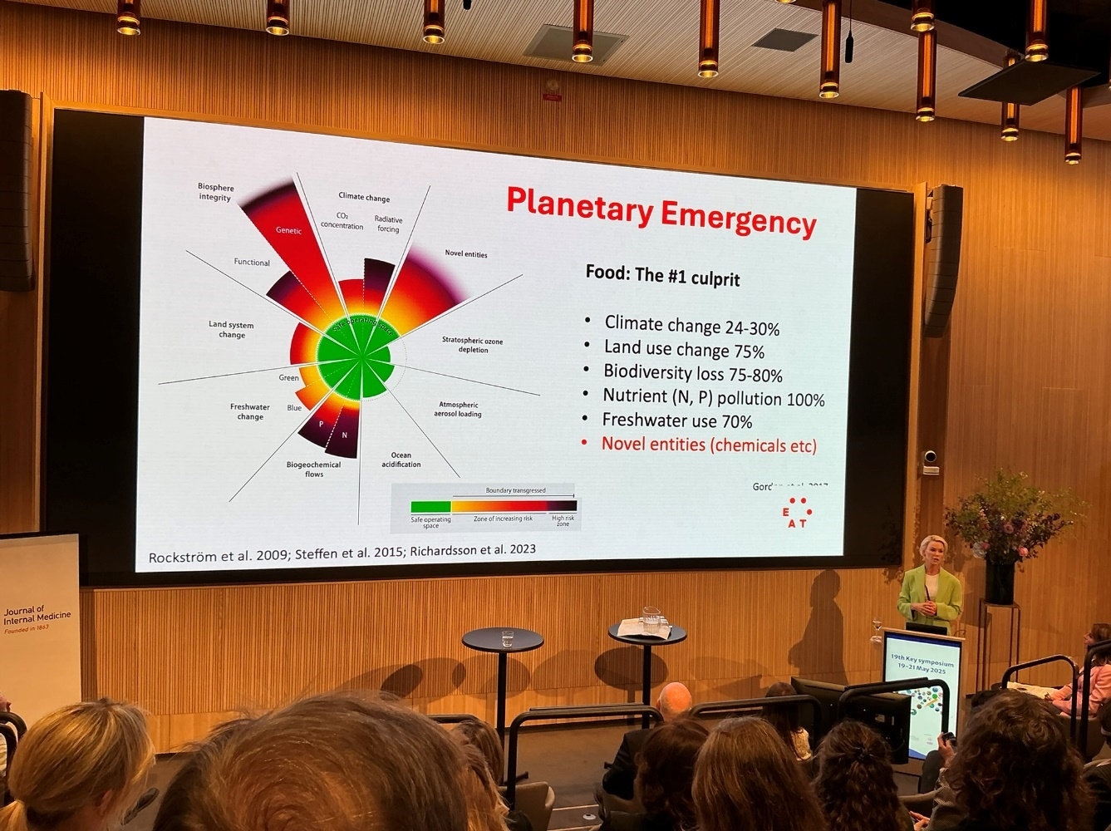
EAT Lancet commission – transformation of eating habits : Brent Loken , Stockholm Resilience Center , brent.loken@wwf.org See EAT-Lancet 2.0 Commission Revises Guidance for Healthy, Diverse Diets, and Sustainable Food Systems Food systems are the nr 1 threat ro people and planet. The cow is not the enemy - but overconsumption of meat. Changes in the diet will vary much depending on region and country. Retailers in Europe should aim at >70% plant base proteins. Present success stories.
Environmentally sustainable diet linked to health benefits : Anna Stubbendorff Researcher in nutrition amd epidemiolog y , Lunds University anna.stubbendorff@med.lu.se

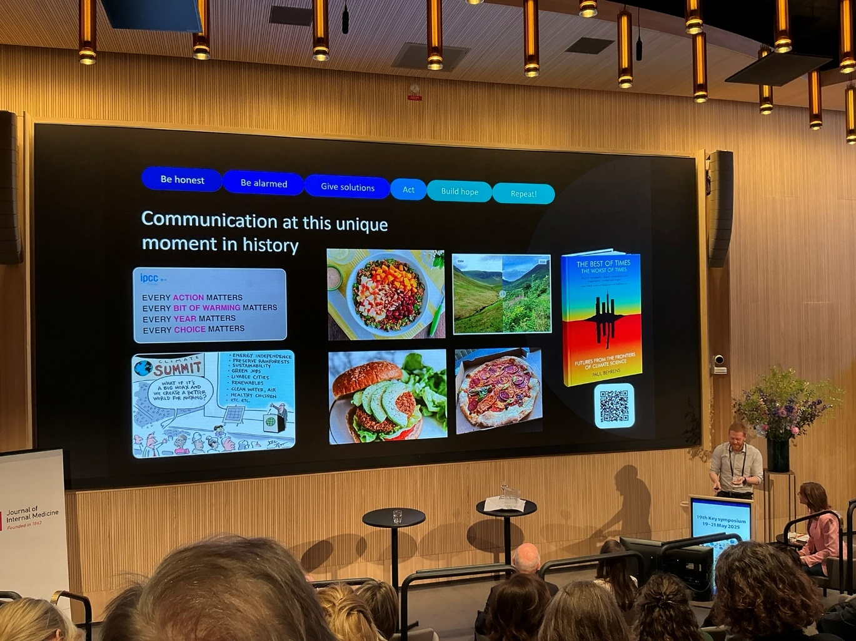
Dual climate benefits from a great food transition. Paul Behrens , Leiden University, Netherlands. p.a.behrens@cml.leidenuniv.nl We need to go plant rich. In Europe 60% of crops are used for feeding animals. Plant-rich diet is the answer.
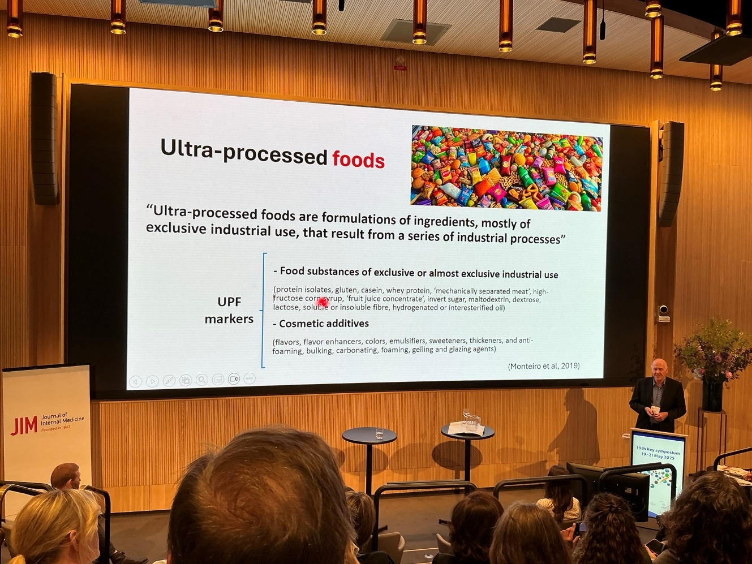
Mark Lawrence, processed food. And ultra processed food (UPF). The trouble with ultra processed food. Three groups of processed food, and the fourth ’ultra processed food’ UPF is reaching 50% of calorie intake in several population’s groups. Brazil has implemented a maximum of UPF i school diet. A GLP-1 analogue drug user decrease the whole household intake of unhealthy food.
Discussion Doctors should be able to prescribe healthy food.

Epidemics of chronic kidney disease in a warmer climate : Annika Wernerson , President Karolinska Institutet , Stockholm, Sweden annika.wernerson@ki.se See Heat‐induced kidney disease: Understanding the impact - Elinder - 2025 - Journal of Internal Medicine - Wiley Online Library
Effects of a changing climate on biological age: Paul Shiels, Professor of Geroscience, University of Glasgow , UK paul.shiels@glasgow.ac.uk Global ageing. Ageing cannot be treated but slowed down. Nrf2 in stress defence is decreased. Glasgow displays large differences in mortality. Ageing starts pre-conception.
Socioeconomic conditions, diet, epigenome, phosphate, low GFR are risk factors for early mortality, gut microphlora.

Climate change and heat related mortality : Bertil Forsberg, Professor i miljömedicin med inriktning på hälsoeffekter av luftföroreningar , Umeå Universitet , Sweden bertil.forsberg@umu.se
Heat related mortality seen also in Scandinavia. Macro Epi results suggest that European cities can cope with high temperatures better nowadays. In North America and Eurpoe we are better equipped and prepared.
Attributing health impacts to climate change: Ana Maria Vicedo Institute of Social and Preventive Medicine, University of Bern, Switzerland anamaria.vicedo@unibe.ch
How much we blame climate change for extreme weather events? Anthropogenic caused global warming attributed with 30 and 70% of heat wave mortality in recent years.
Fossil fuels as a threat for planetary health Francesca Costabile, Institute of Atmospheric Sciences and Climate- National Research Council, Rome, Italy f.costabile@isac.cnr.it
Health burden from different sources of air pollution: Jos Lelieveld , director of the Atmospheric Chemistry Department at the Max Planck Institute for Chemistry of Mainz, Germany jos.lelieveld@mpic.de
Short and long- lived climate pollutants (CO 2 vs. CH 4 ). Raymond Pierrehumbert University of Oxford Department of Physics , UK raymond.pierrehumbert@physics.ox.ac.uk
Role of aerosols in climate change Kevin Noone Dept of Environmental Science, Stockholms University kevin.noone@aces.su.se
Water and health in the future climate: Berit Arheimer Head of Hydrological Research at SMHI , Norrköping berit.arheimer@smhi.se
Amazon rainforest and its implications on humans health: Carlos Nobre, emeritus, Earth system scientist, cnobre.res@gmail.com
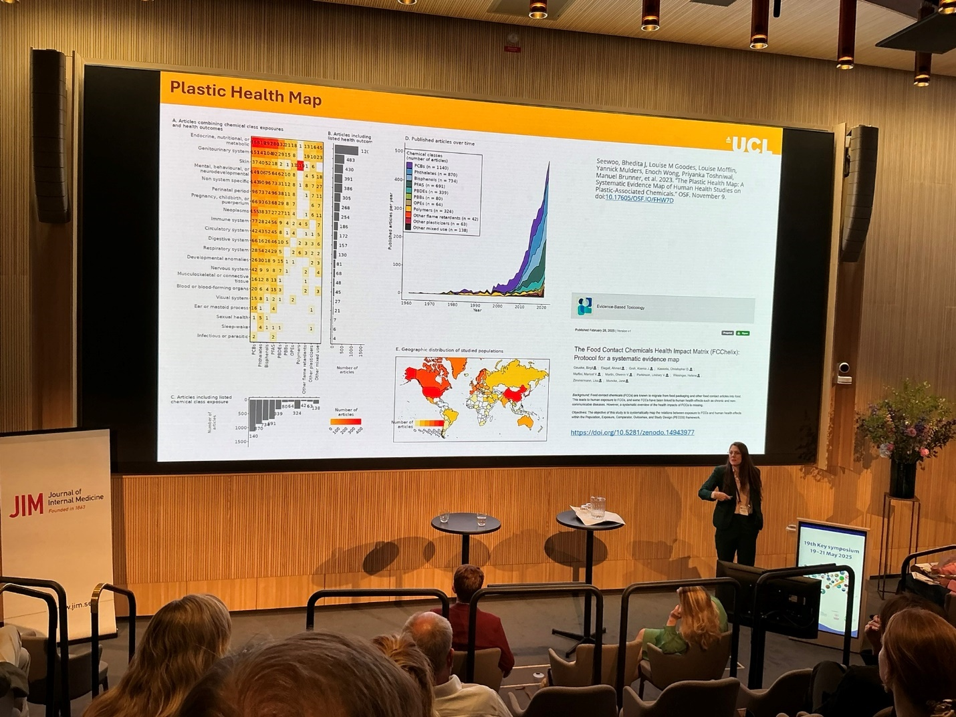
Water, sanitation, and hygiene: Sarah Dickin Lecturer at Department of Women's and Children's Health sarah.dickin@sei- international.org sarah.dickin@uu.se Uppsala University
Plastics and our future health; Olwenn Martin, Scientific expertise to the UK Health and Safety Executive, the UK Food Standards Agency, UK. Natural polymers. Amber, rubber. Today 600 synthetic plastic polymers. Macro and nano plastic particles MNPs are found all over the world as well as in animal and human tissues. Composition, size and structure determines effects

The health risks of human- made chemicals in the environment; Pauliina Damdimopoulou , Senior Lecturer in Reproductive and Perinatal Toxicology pauliina.damdimopoulou@ki.se
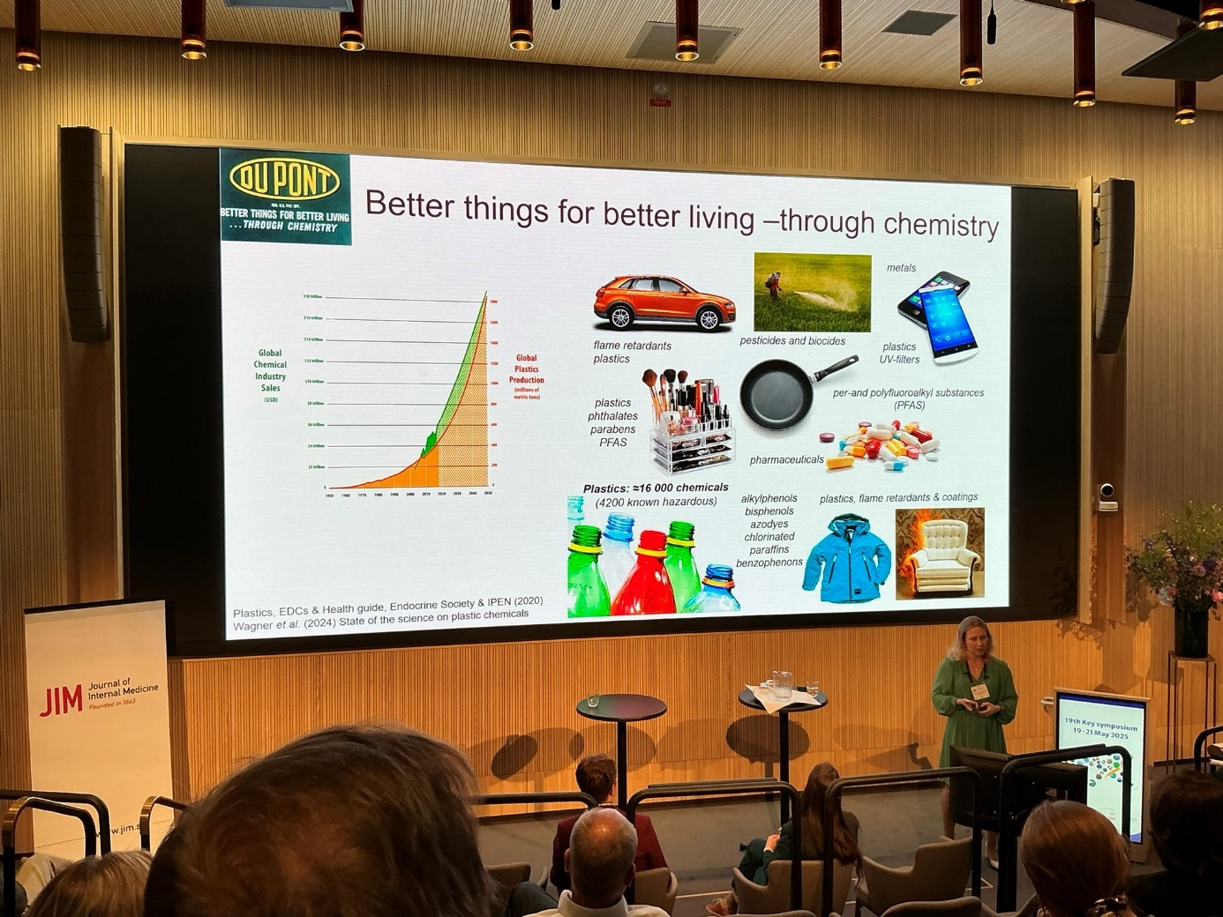
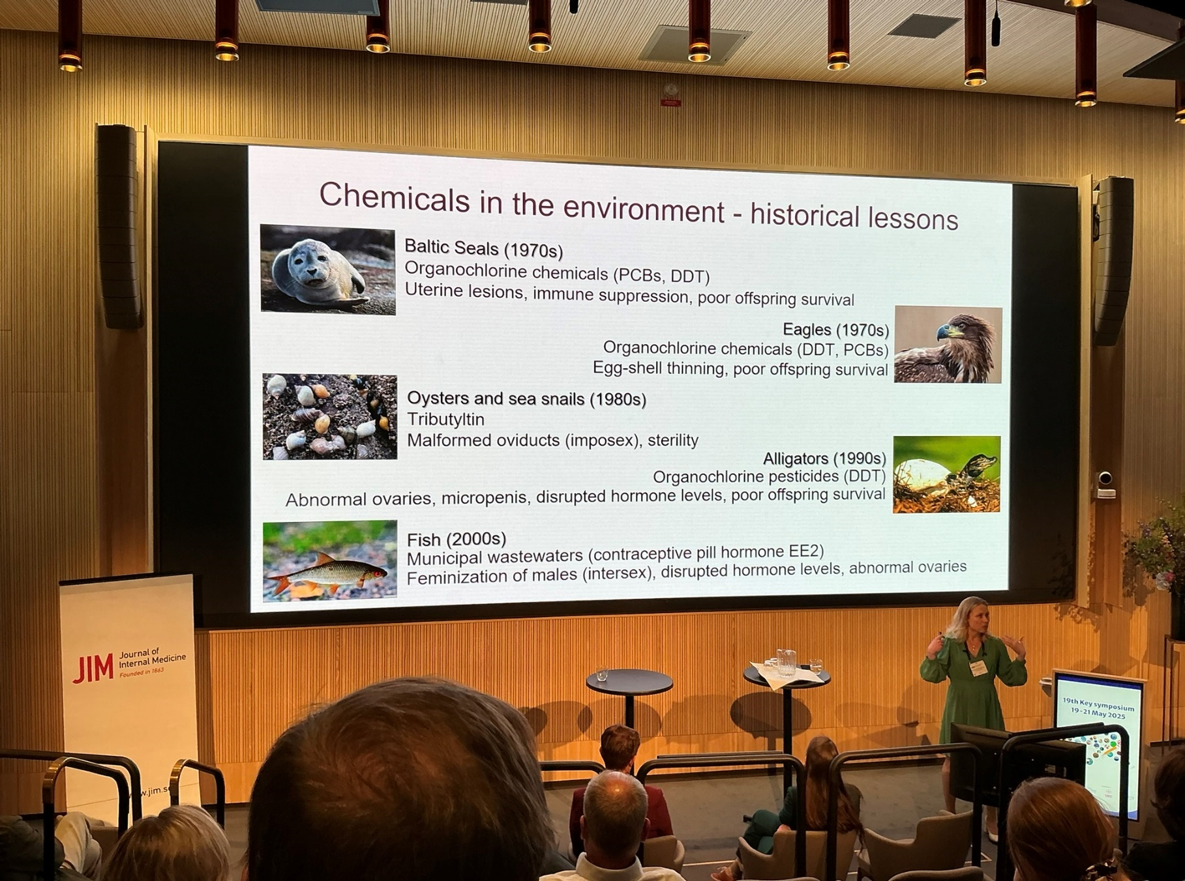
The Global Plastics Treaty – the role of endocrine disruptive chemicals Leonardo Trasande Professor of Pediatrics, Department of Population Health leonardo.trasande@nyulangone.org Plastics are a global health issue. Invisible chemicals and particles comprise major risk. If we burn plastic we create dioxins. Lower IQ in children, make conclusions from macro epidemiological studies. Endocrine disruptions and lowered fertility. 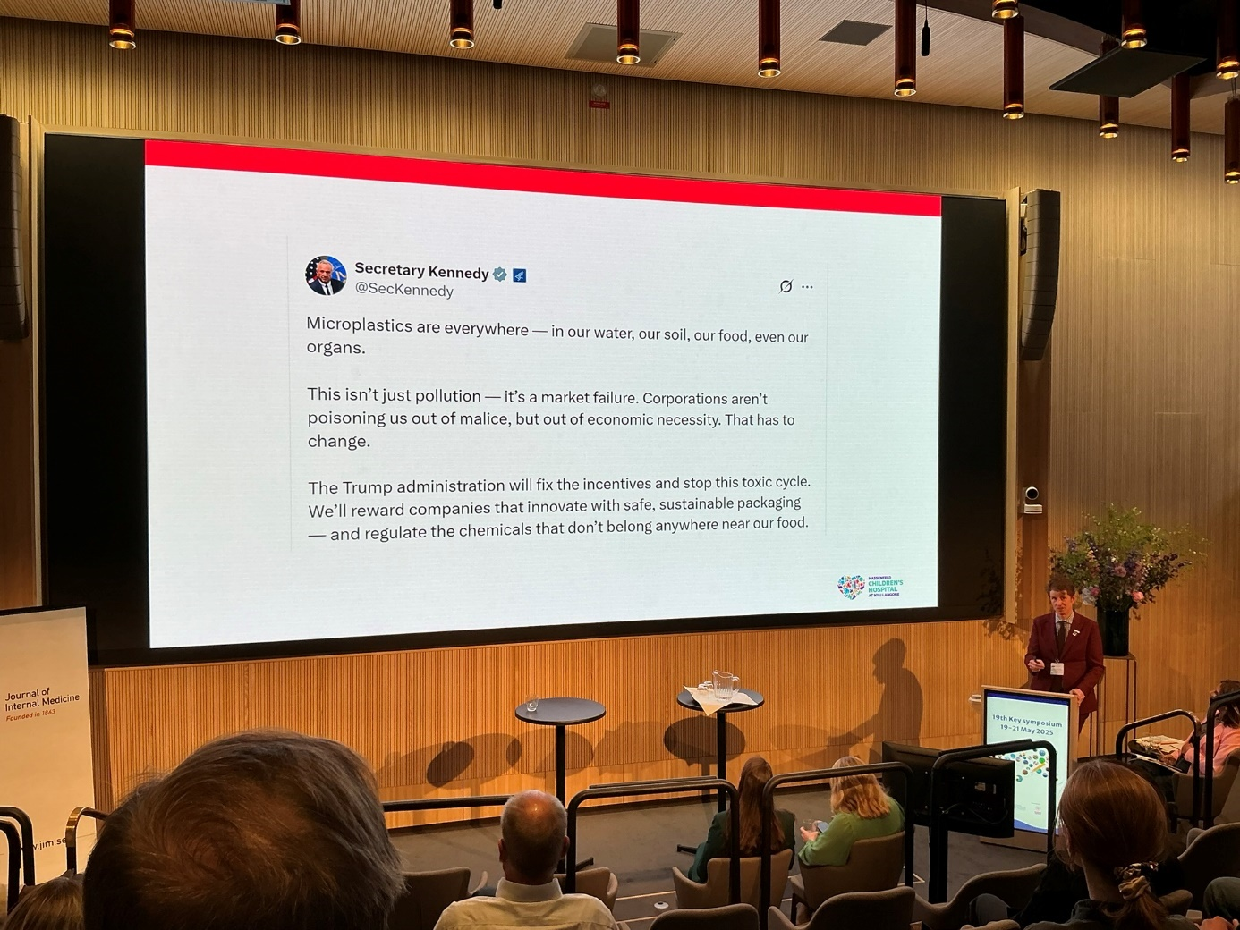
What is life? Ingemar Ernberg, Professor, Tumor Biology, Karolinska Institutet, Stockholm ingemar.ernberg@ki.se No clear definition. Lectures available on the web.
Life is Networks, relations and interactions. Jacob Berzelius realised dynamics and catabolism. Leonardo da Vinci was coined oceanic world within the body. DNA in isolation does nothing. Transcription and epigenetics. Intracellular networks. Life is networks. see Philip Bill How life works. We inherit not only DNA but also the network! The cell with all its organelles. Life construct itself into the adjacent possible. Genes are merely participants in the intracellular network.
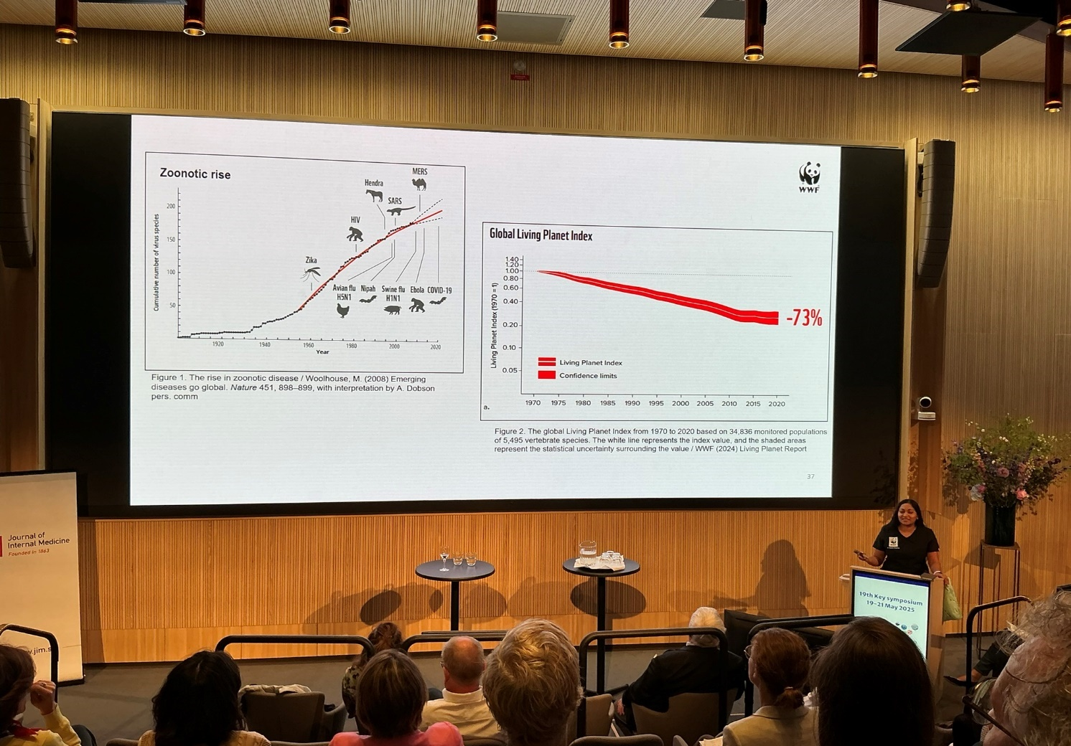
Biodiversity and Health: The risks and opportunities ? Prishani Vengetas , Senior adviser World Wildlife Foundation, Australia pvengetas@wwfint.org conservation veterinarian. WWF are planetary health workers!
Can natures intelligence be used to improve human health? Peter Stenvinkel, Karolinska Institutet , Stockholm. Kidney health critical. Environmental destruction will cause premature ageing. See photos
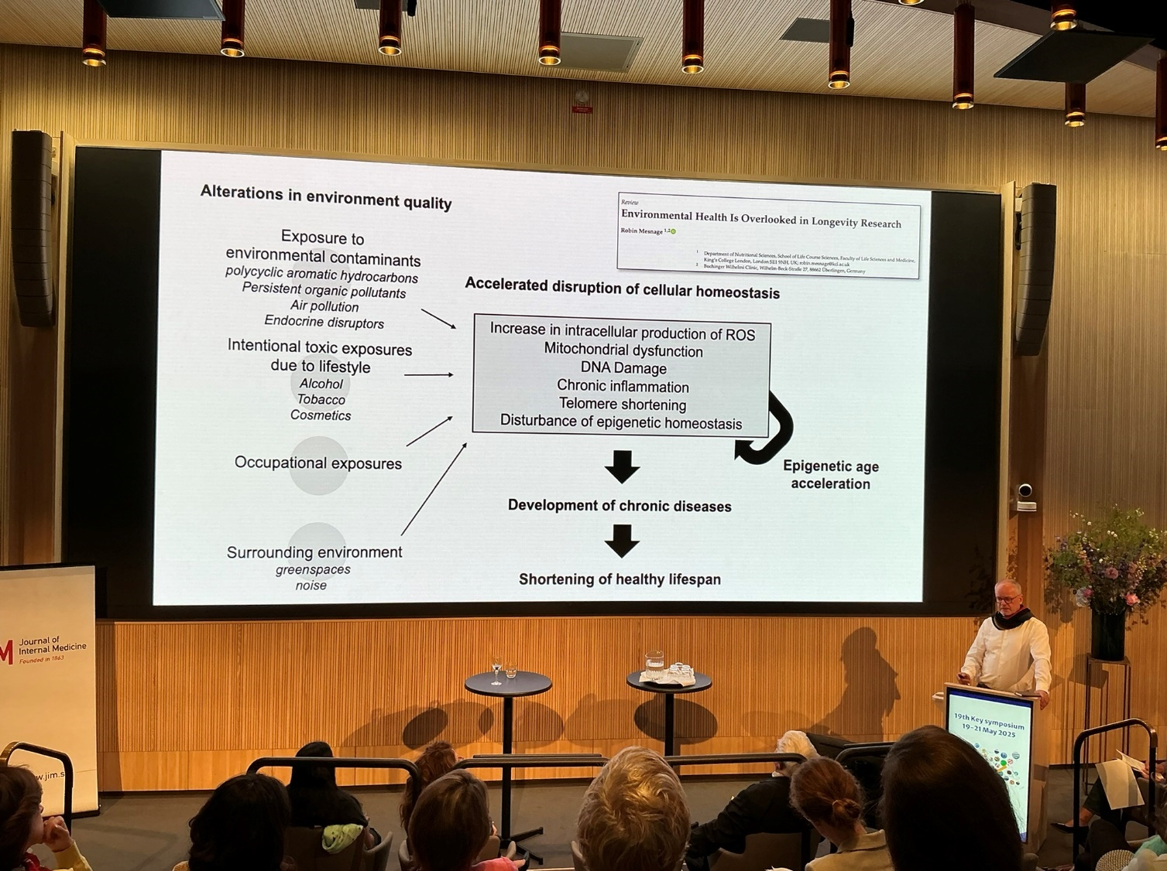
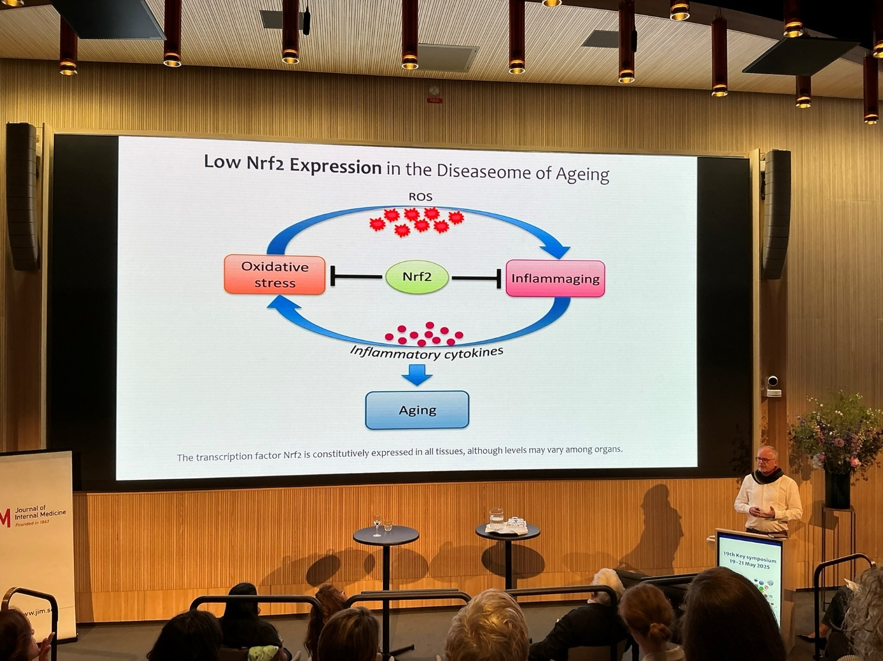
Lessons from nature – how to use fat to make water: Rick Johnson, University of Colorado, Denver , USA richard.johnson@ucdenver.edu Water is essential for animal life. Often water has to be stored. Vasopressin concentrates the urine. Fat, and glycogen, are sources of water. Whales get water from fat. Vasopressin is high in obesity. Is a fattening hormone. Obese are often dehydrated. Fructose activates eating drive. Vasopressin stimulates forage. Increase in blood pressure, ACTH etc. Vasopressin is high before hibernation.

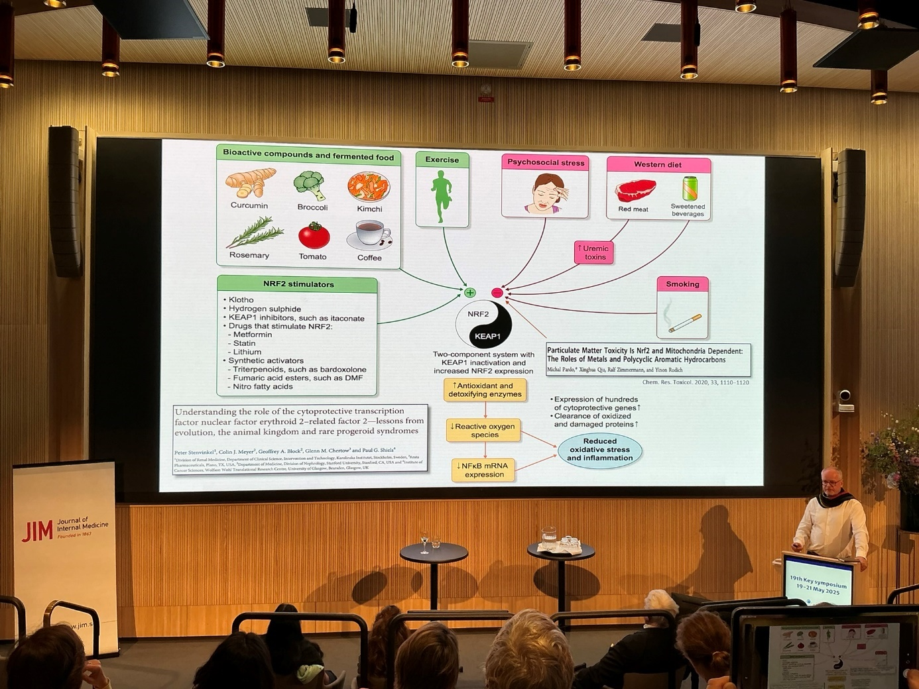
Insect ecology and insect- mediated ecosystem: Fabrizia Ratto, Ecologist, Centre for Sustainable Agricultural Systems , University of London UK , Fabrizia.Ratto @ rhul.ac . uk Discussion More than a million species of insects. Biocontrol is more effective than pesticides.
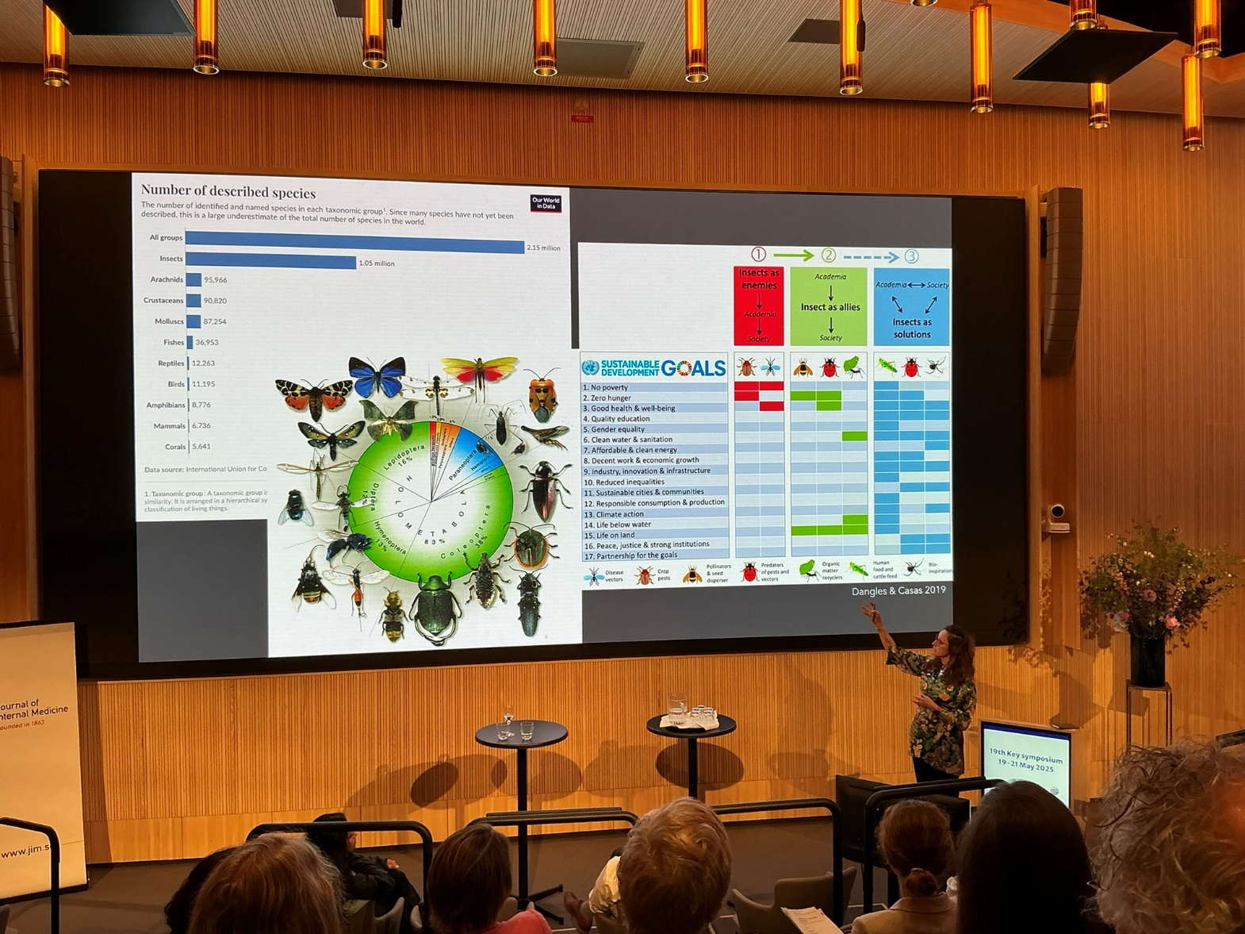Lost Name Investing in planetary health in Asia. Asia holds 60 % of the worlds population. All infrastructure is about climate, nature and health. Nature must be incorporated. Invest in mangroves. Reforestation implemented successfully in large part of China. The number of coalfired plants has decreased. In Delhi air has improved after introduction of shutdowns.
The possibility of decolonising planetary health: exploring new geographies for collaboration; Dawn Hoogeveen, Faculty of Health Sciences, Simon Fraser University, Burnaby BC, Canada dhoogeve@sfu.ca Indigenous populations. Look as nature as ’relatives’. Storyline, mindset, and technology: three key ingredients for transformative change:
Communicating planetary health; Julia Serong Ludwig- Maximilians- University of Munich Institut für Kommunikationswissenschaft und Medienforschung , Germany julia.serong@ifkw.lmu.de is a communicating scientist. What is the goal. Needs listening as well.
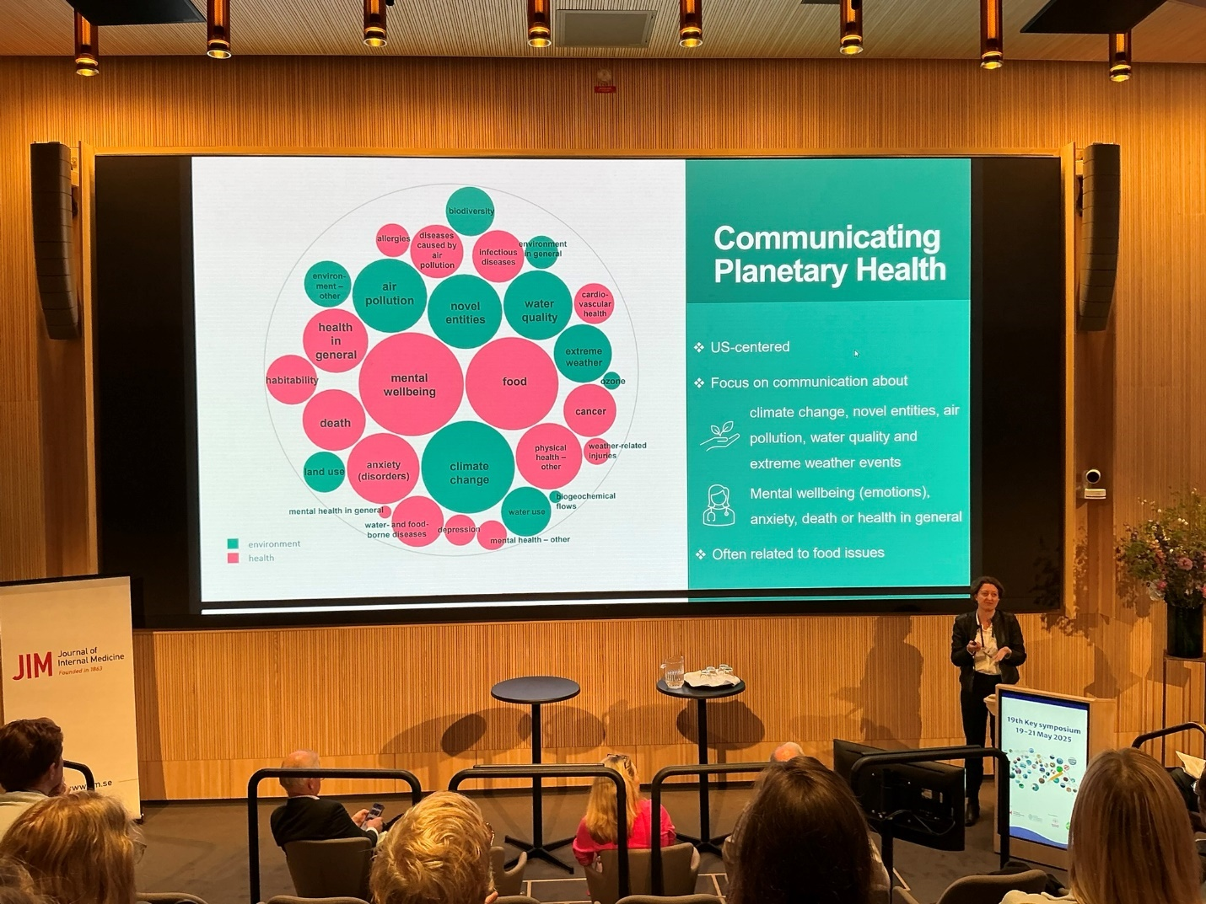
Emelie Antoni Astra Zeneca Healthcare in a changing world. Nordic Country President. Uppvuxen i västkusten. Tech health impact of climate change, rising prevalence of chronic disease, ageing population. Health care is part of the solution but also the problem. Health sector responsible for 5% of the global co2 emissions. 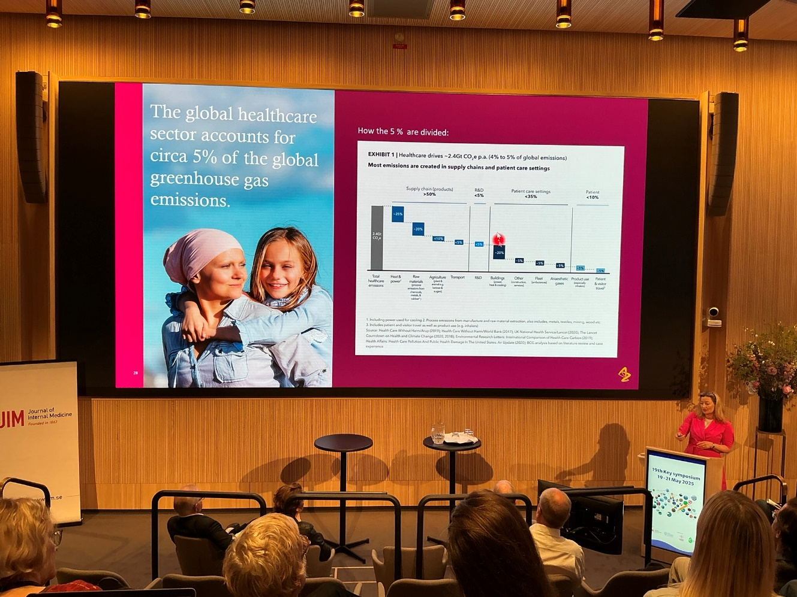

Breaking the silos – how can we work on planetary health in academia? Ole Petter Ottersen, Former president University of Oslo and Karolinska Institutet, Norway ole.petter.ottersen@ki.se Some light in the tunnel.
My personal comment from this conference
To Peter, Bo, and the organising committee of 19th Key Symposium: Planetary Health – connect the dots. What saves the planet saves our health

I am humble and overwhelmed after closure of the conference meeting on Planetary Health – Connect the Dots. Locality, setting, and lecture hall was excellent. Wide range of lectures, all pertinent to the theme, and understanding, of Planetary Health. Excellent possibilities to meet and discuss with lecturers as well as all other participants. Very well chaired and lead conference in a friendly communicative scientific atmosphere albeit the alarming and urgent issues and problems addressed during the meeting on Planetary Health, connecting the dots also, in my professional life.

My personal comment from this conference
Reading Rachel Carson made me a birdwatcher and environmentalist in upper secondary school in the end of the 1960-ties. Initially I planned to study ecology and biology to become a researcher in these fields, to make a change. But I was advised, by elders, that ‘people are more concerned about their own health than nature, birds and wildlife and listening to birdwatching environmentalists’. So instead, I decided to start med school and to become an environmental health researcher with a medical background. Early in my medical studies in Karolinska Institutet, parallel with my medical curriculum, I started as an assistant at the Department of Environmental Medicine. Graduated from med school in 1978 and presented a thesis on Renal Effects of Cadmium in 1979. Become specialist and professor in Occupational Medicine at the National Institute for Occupational Health 1985. But felt that my research field was narrowing as occupational chemical exposures went down and health risks from chemical and exposures in Sweden as well. A bit like doing research in an Ivory tower. So, I decided to become a clinician instead and become specialist in internal and renal medicine at the Karolinska University Hospital. Still doing research, now mainly renal epidemiology. Eventually become head of the Department of Renal Medicine and professor in Nephrology at Karolinska Institutet. But still being a birdwatcher and environmentally concerned. The last 15 years doing research on a new type of kidney disease that was shown to be heat induced.
At this recently held conference I have realized how close human health, biodiversity, climate, and planetary health are associated. I might have participated in this fantastic conference also if I in 1971 had started training in biology and ecology. The dots in my professional carrier are also connected!
I am so happy and pleased that the organizing committee invited me to participate.
Thank you all!

